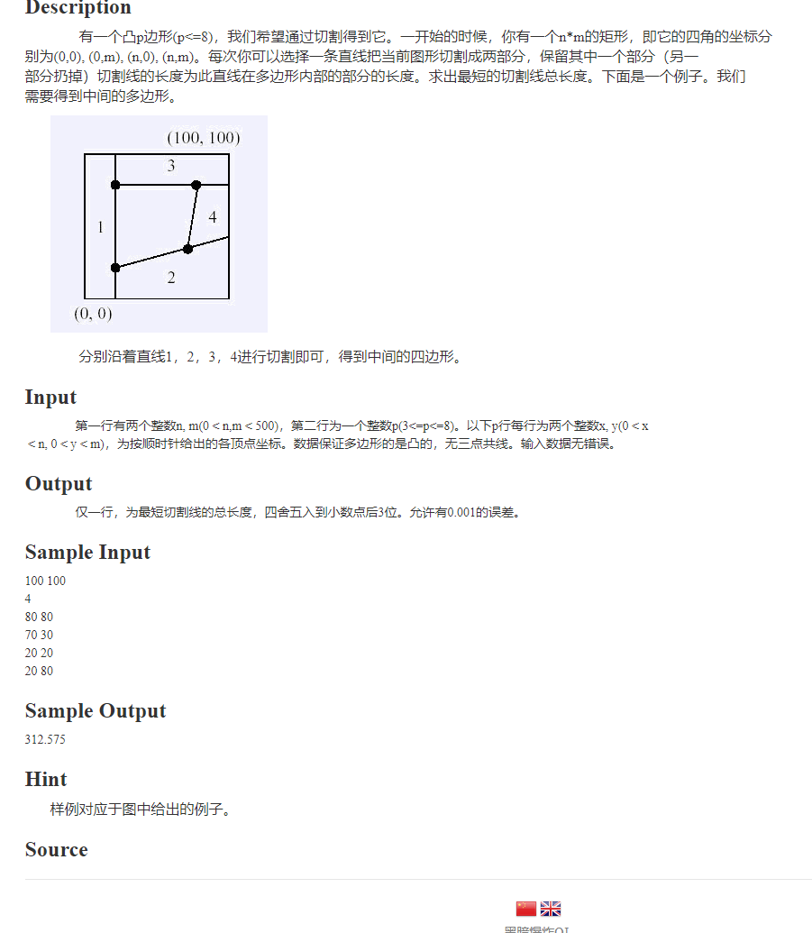

第一遍敲完后发现pos的坐标忘记转化了，然后测了样例感觉没问题就交了。
结果WA5 ，一直不知道为什么，最后是边界问题没处理，然后还有就是只能更新点左边，和另一个点右边。 怎么判断呢？
if(dis(tmp,a)<dis(tmp,b)&&dis(tmp,a)<now1)
{
now1=dis(tmp,a);
}
if(dis(tmp,b)<dis(tmp,a)&&dis(tmp,b)<now2)
{
now2=dis(tmp,b);
}
这样就好了
#include<bits/stdc++.h>
#define ll long long
using namespace std;
const int N=300;
int cnt=0;
const double INF=0x3fffffff;
struct line
{
double k;
double d;
double x;
};
line L[N];
line res[N];
line getline(double x1,double y1,double x2,double y2)
{
line tmp;
if(x2==x1)
{
tmp.x=x2;
tmp.k=0.0;
tmp.d=0.0;
}
else
{
tmp.x=-1.0;
tmp.k=(y2-y1)/(x2-x1);
tmp.d=y1-tmp.k*x1;
}
return tmp;
}
struct node
{
double x,y;
}e[N];

double dis(node a,node b)
{ double x1=a.x;double y1=a.y;
double x2=b.x;double y2=b.y;
return sqrt((x1-x2)*(x1-x2)+(y1-y2)*(y1-y2));
}
node jiaodian(line a,line b)
{ node tmp;
if((a.x==-1.0)&&(b.x!=-1.0))
{
tmp.x=b.x;
tmp.y=b.x*a.k+a.d;
return tmp;
}
if((a.x!=-1.0)&&(b.x==-1.0))
{
tmp.x=a.x;
tmp.y=a.x*b.k+b.d;
return tmp;
}
if((a.x!=-1.0)&&(b.x!=-1.0))
{
tmp.x=-1.0;
tmp.y=-1.0;
return tmp;
}
if(a.k==b.k)
{
tmp.x=-1.0;
tmp.y=-1.0;
return tmp;
}
tmp.x=(b.d-a.d)/(a.k-b.k);
tmp.y=tmp.x*a.k+a.d;
return tmp;
}int ct=1;double n,m;
double doit(node a,node b,line now)
{
double now1=INF; double now2=INF;
for(int i=1;i<=cnt;i++)
{
node tmp=jiaodian(res[i],now);
if((tmp.x<0.0)||(tmp.x>n)||(tmp.y<0.0)||(tmp.y>m)) continue;
// cout<<tmp.x<<" "<<tmp.y<<endl;
//if(ct==36027) cout<<"jiaodian: "<<tmp.x<<" "<<tmp.y<<endl;
if(dis(tmp,a)<dis(tmp,b)&&dis(tmp,a)<now1)
{
now1=dis(tmp,a);
}
if(dis(tmp,b)<dis(tmp,a)&&dis(tmp,b)<now2)
{
now2=dis(tmp,b);
}
}
return now1+now2+dis(a,b);
}
int main()
{

scanf("%lf %lf",&n,&m);
int p;
scanf("%d",&p);
for(int i=1;i<=p;i++)
{
scanf("%lf %lf",&e[i].x,&e[i].y);
}
for(int i=1;i<=p;i++)
{ line tmp;
if(i!=p)
tmp=getline(e[i].x,e[i].y,e[i+1].x,e[i+1].y);
else tmp=getline(e[i].x,e[i].y,e[1].x,e[1].y);

L[i]=tmp;
}
cnt=4;
line tmp;
tmp.k=0.0; tmp.d=0.0;tmp.x=-1.0; res[1]=tmp;
tmp.k=0.0; tmp.d=m; tmp.x=-1.0; res[2]=tmp;
tmp.x=0.0; res[3]=tmp;
tmp.x=n; res[4]=tmp;

int a[10];
for(int i=1;i<=9;i++) a[i]=i;
double ans=INF;
//debug
//a[1]=3; a[2]=2; a[3]=4; a[4]=1;

do
{ cnt=4;double noww=0.0;

for(int i=1;i<=p;i++)
{
int pos=a[i];
node tmp1;
node tmp2;
if(pos!=p) {tmp1.x=e[pos].x; tmp1.y=e[pos].y; tmp2.x=e[pos+1].x; tmp2.y=e[pos+1].y;}
else {tmp1.x=e[pos].x; tmp1.y=e[pos].y; tmp2.x=e[1].x; tmp2.y=e[1].y;}
noww+=doit(tmp1,tmp2,L[pos]);
res[++cnt]=L[pos];

}
ans=min(ans,noww);

ct++;
//if(ct>=100&&ct<=200) {cout<<ans<<endl;ct++;}
//else ct++;

}while(next_permutation(a+1,a+1+p));
printf("%.3lf",ans);
return 0;
}

